**CHECKSUM RSYNC TESTING**

# Src & Trgt

Src => /entimice/nochecksumtest/src => 8.8G

Trgt => /entimice/nochecksumtest/trgt => 0

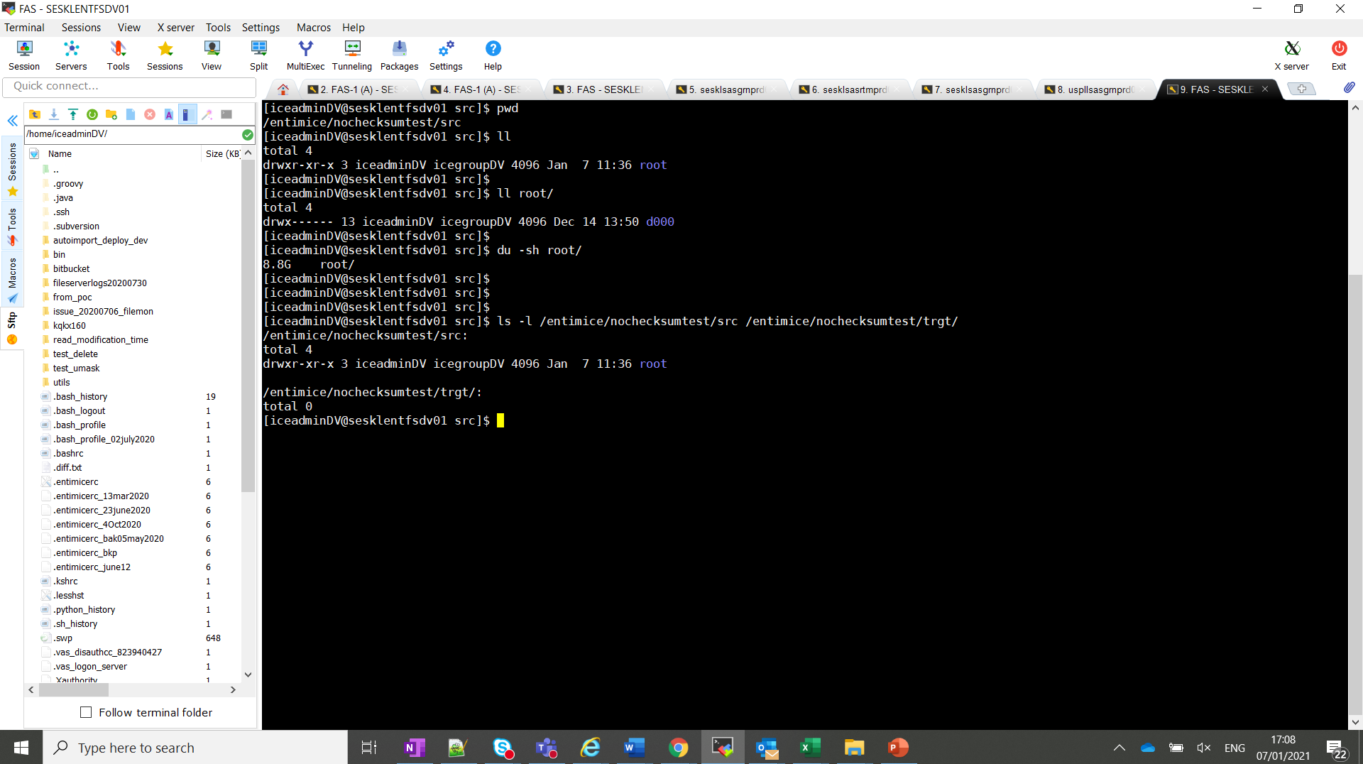

# Initial Full Transfer with checksum option

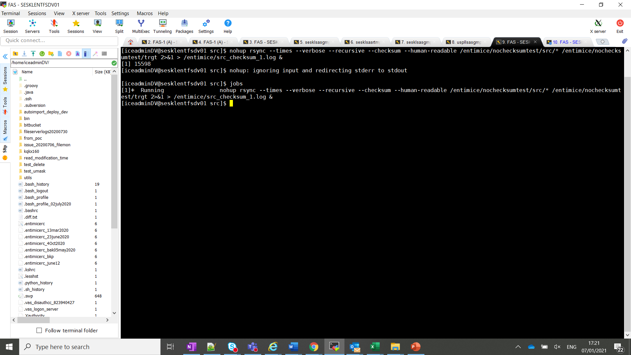

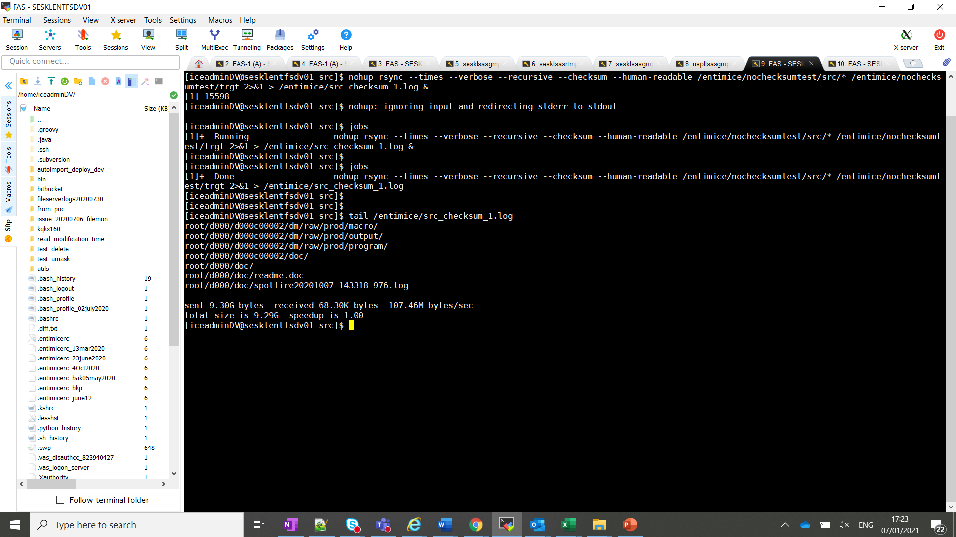

sent 9.30G bytes received 68.30K bytes 107.46M bytes/sec

total size is 9.29G speedup is 1.00

# Incremental rsync WITH checksum option after adding another directory to the src location

## Add another directory

Src => /entimice/nochecksumtest/src => 8.8G+7.8G (new)

Trgt => /entimice/nochecksumtest/trgt => 8.8G

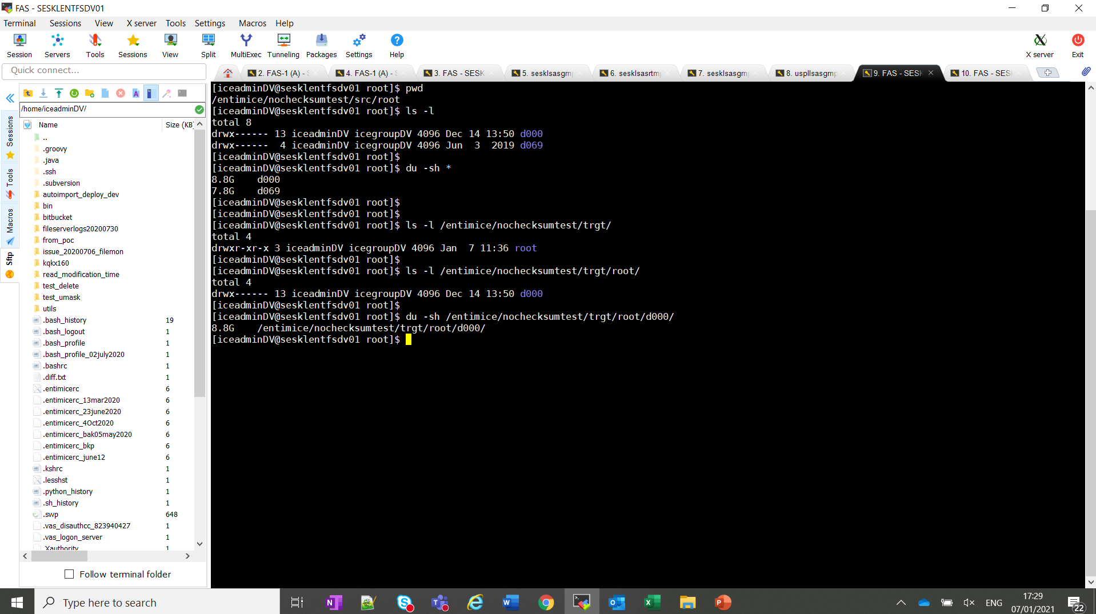

## Initiate Incremental Transfer WITH checksum option

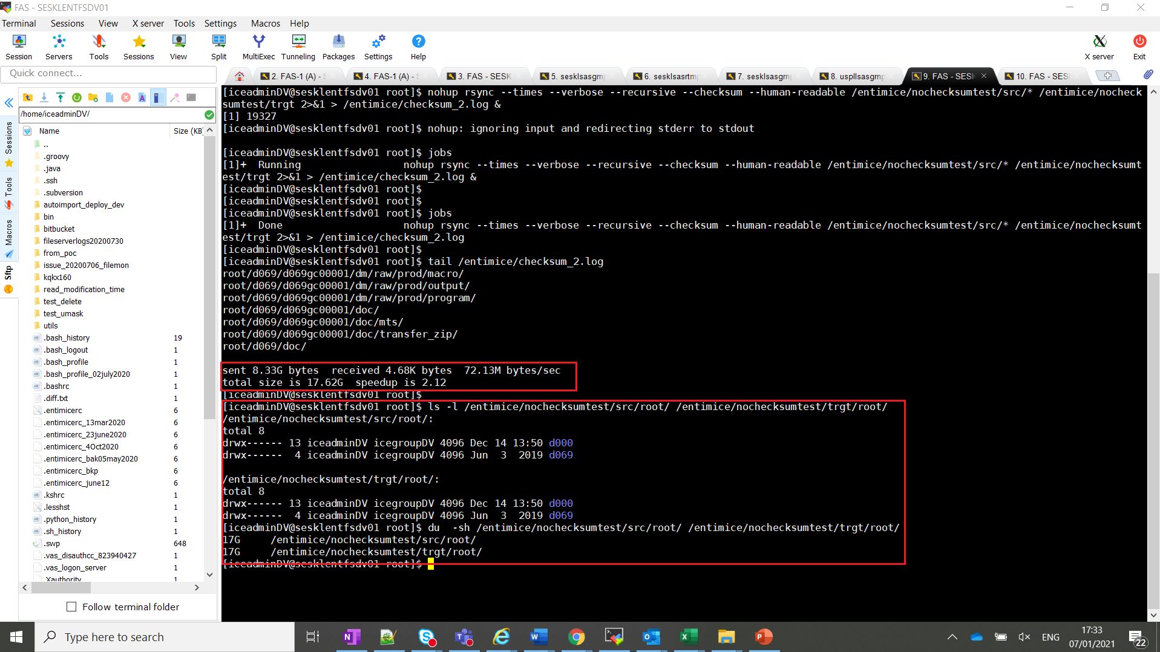

## Transfer Rate WITH checksum

sent 8.33G bytes received 4.68K bytes 72.13M bytes/sec

total size is 17.62G speedup is 2.12

# Delete the newly added directory at trgt only

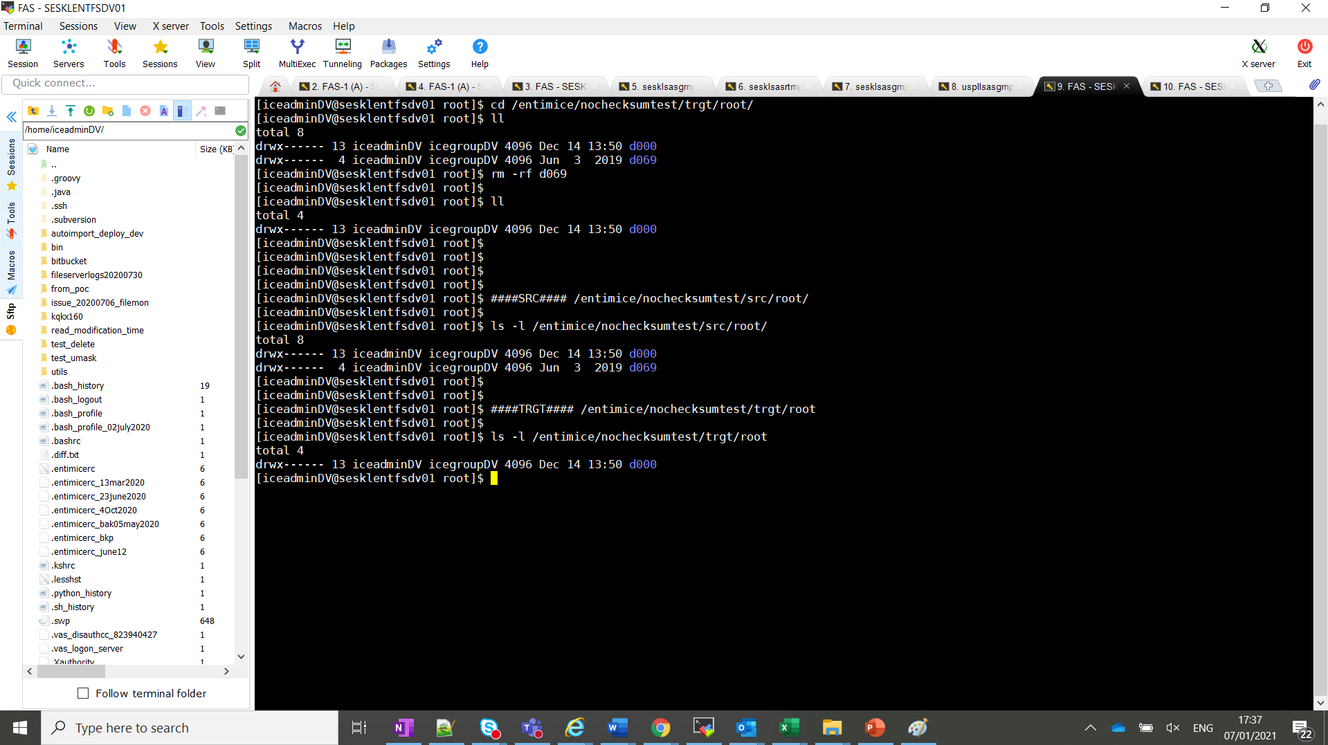

# Incremental rsync WITHOUT checksum option

## a. Initiate Incremental Transfer WITHOUT checksum option

Src => /entimice/nochecksumtest/src => 8.8G+7.8G (new)

Trgt => /entimice/nochecksumtest/trgt => 8.8G

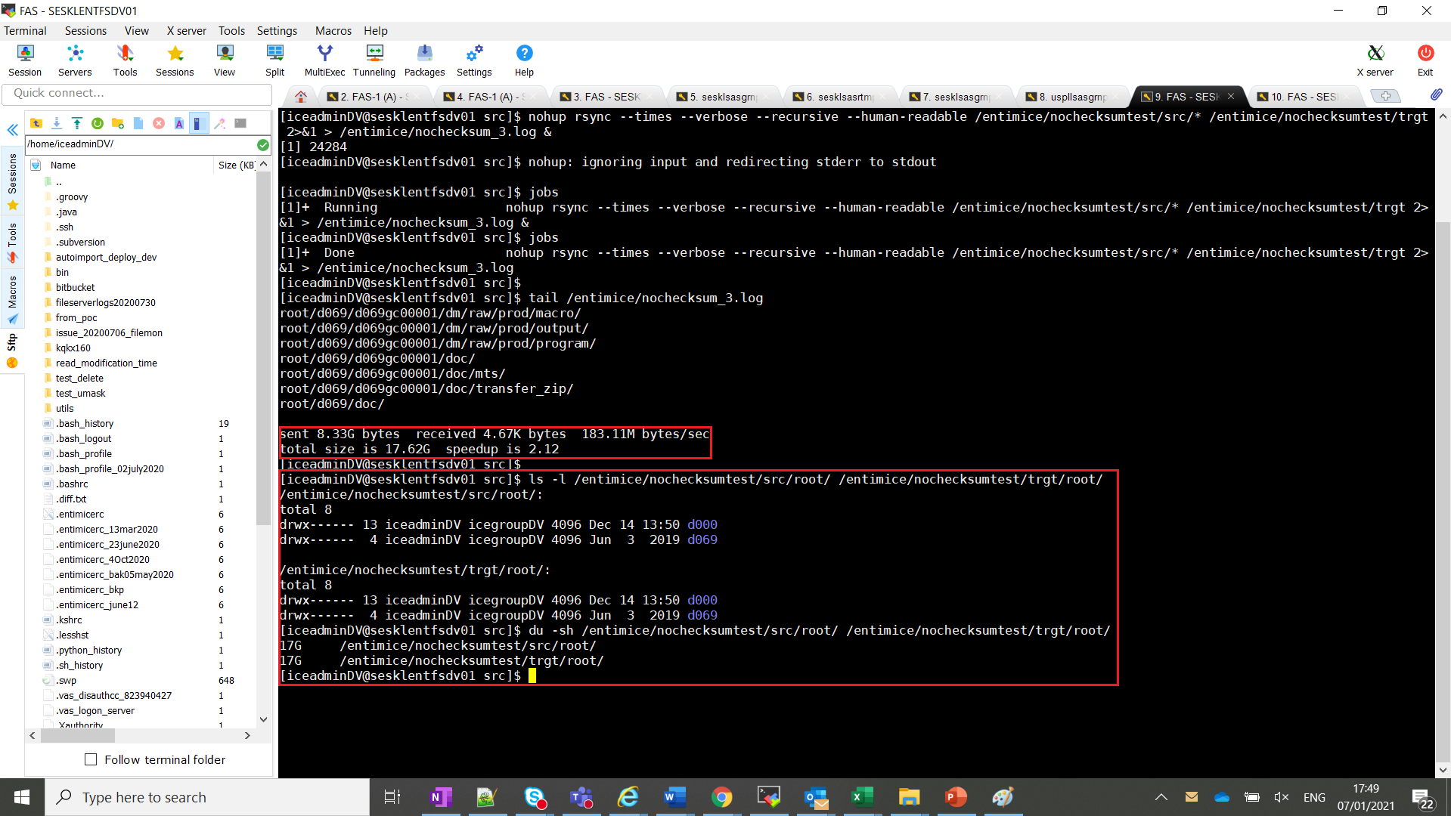

## Transfer Rate WITHOUT checksum option

sent 8.33G bytes received 4.67K bytes 183.11M bytes/sec

total size is 17.62G speedup is 2.12

# Conclusion

**Transfer rate with checksum**

sent 8.33G bytes received 4.68K bytes 72.13M bytes/sec

total size is 17.62G speedup is 2.12

**Transfer rate without checksum**

sent 8.33G bytes received 4.67K bytes 183.11M bytes/sec

total size is 17.62G speedup is 2.12

With 8 GB incremental test WITHOUT nochecksum option, we are seeing 254% increased transfer rate.